**LAPORAN TUGAS AHIR**

Mata Kuliah Pemrograman Berorientasi Objek

**Judul Projek**

**MANAGEMENT HOTEL MADRIDISTAS**



Disusun Oleh:

1. Ichsan Azala Walanadza 2213020076
2. Rahel Robin Sugiarti 2213020088
3. Shafira Putri Agustina 2213020131

PROGRAM STUDI TEKNIK INFORMATIKA

FAKULTAS TEKNIK DAN ILMU KOMPUTER

UNIVERSITAS NUSANTARA PGRI KEDIRI

TAHUN 2023

# DAFTAR ISI

DAFTAR ISI 2

FLOWCHAT SISTEM MENEGEMENT 4

HOTEL MADRIDISTAS 4

CLASS DIAGRAM MENEGEMENT 5

HOTEL MADRIDISTAS 5

HASIL PROGAM DAN PENJELASAN 6

1. Main Menu 6

a) Tampilan 6

b) Deskripsi Main menu 6

c) Detail Main Menu 7

2. Form Login 19

a) Tampilan 19

b) Deskripsi Form Login 19

C) Detai Aplikasi 19

2. Form Transaksi 23

A. Booking Kamar 23

B. Edit / Update 31

3.Form Chek In/Out 45

a) Tampilan 45

b)Deskripsi Form Check In/Out 45

c)Detail Check in/out 45

4.Income / Laporan keuangan perbulan 52

a) Tampilan 52

b) Komponen Visual, Text dan Variabel 52

c) Source Code 53

QUERY 56

Menampilkan form 56

1. Booking 56

2. Edit 56

3. Check In/Out 57

Fungsi tombol 58

1. Submit booking 58

2. Edit 59

3. Delete 60

4. Chek in/out 60

DAFTAR PUSTAKA 61

# FLOWCHAT SISTEM MENEGEMENT

# HOTEL MADRIDISTAS

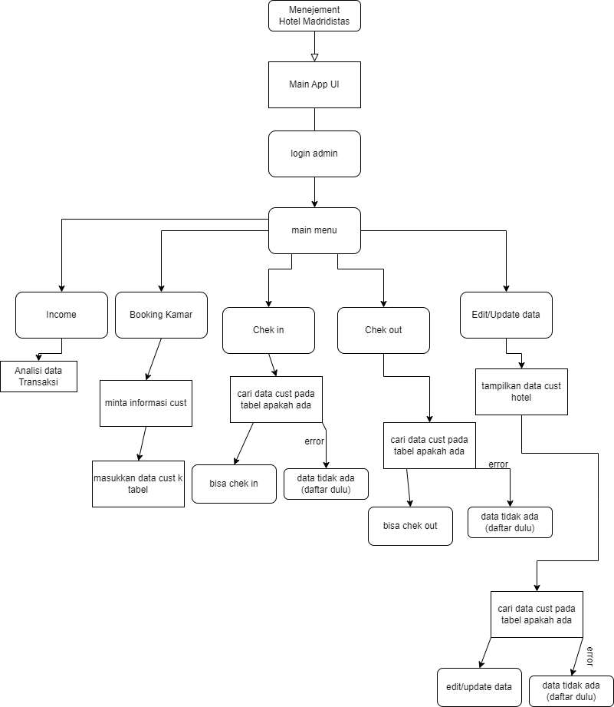

# CLASS DIAGRAM MENEGEMENT

# HOTEL MADRIDISTAS

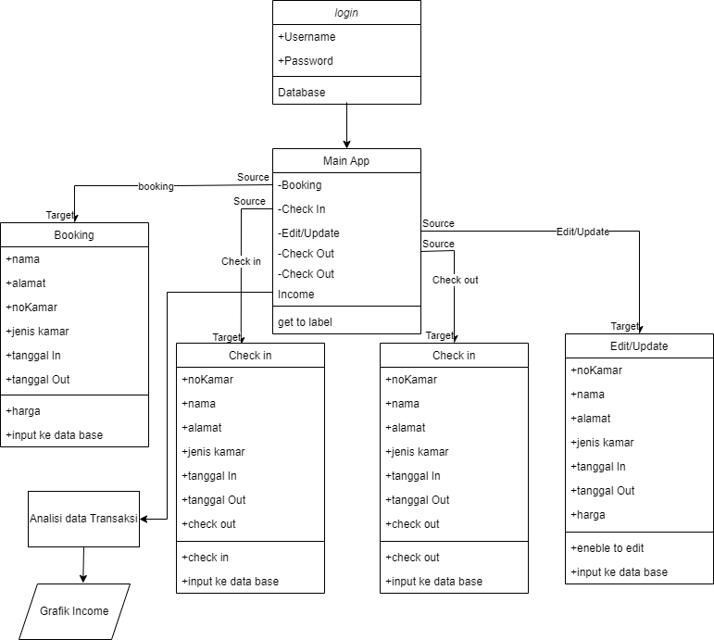

# HASIL PROGAM DAN PENJELASAN

## 1. Main Menu

### a) Tampilan

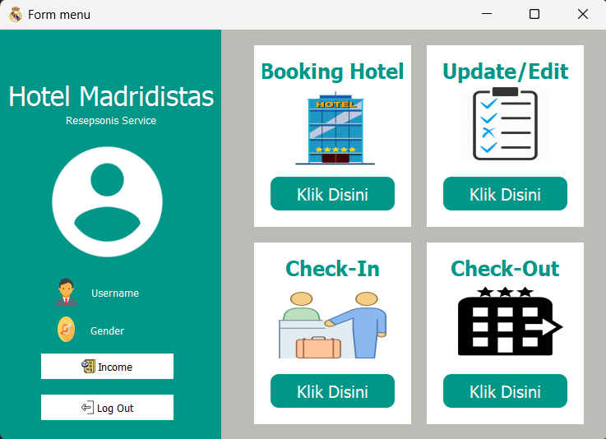

### b) Deskripsi Main menu

Tampilan dari menu ini adalah antarmuka pengguna (UI) untuk suatu aplikasi atau sistem yang terdiri dari dua bagian utama. Bagian pertama terletak di sebelah kiri dan diberi nama "FrameAkun," sementara bagian kedua terletak di sebelah kanan dan disebut "FrameMenu."

Semua elemen pada antarmuka ini dirancang dengan warna latar belakang putih dan warna teks hitam atau sesuai spesifikasi tertentu. Selain itu, terdapat ikon dan gambar yang memberikan tampilan visual pada setiap bagian menu.

### c) Detail Main Menu

- Komponen Visual, text dan Variabel

|  |  |  |
| --- | --- | --- |
| Komponen Visual | Text | Variabel |
| Logo Hotel | - | - |
| Title Hotel | Hotel Madridistas | - |
| Logo User | - | - |
| Username | Username | - |
| BtnIncome | Income | PopLapIncome |
| BtnBoking | Booking | MenuBooking() |
| Logo Booking | - | - |
| BtnCheckin | Check In | MenuCheckIn() |
| Logo Check in | - | - |
| BtnLogOut | Logout | PopUpLogOut() |
| BtnUpdate | Edit/update | MenuEdit() |
| Logo Update | - | - |
| BtnCheck Out | Check Out | PopCheckout |
| Logo Check Out | - | - |

- Source Code

1. Tombol Income

|  |
| --- |
| Buat Tampilan  Source file: MainMenu.py  Source class: Ui_Form  self.BtnIncome = QtWidgets.QPushButton(self.FrameAkun)          self.BtnIncome.setGeometry(QtCore.QRect(50, 395, 161, 31))          font = QtGui.QFont()          font.setFamily("Sans Serif")          self.BtnIncome.setFont(font)          self.BtnIncome.setCursor(QtGui.QCursor(QtCore.Qt.PointingHandCursor))          self.BtnIncome.setStyleSheet("QPushButton{\n"  "background-color: rgb(255, 255, 255);\n"  "color:black;\n"  "border-style:outset;\n"  "border-radius:20px;\n"  "}\n"  "QPushButton::hover{\n"  "background-color: rgb(204, 0, 0);\n"  "color:white;\n"  "border-style:outset;\n"  "border-width:2px;\n"  "border-radius:20px;\n"  "border-color: rgb(255, 255, 255);\n"  "}")          icon = QtGui.QIcon()          icon.addPixmap(QtGui.QPixmap("C:\\Users\\shafira\\Documents\\New folder\\project pbo\\fix\\img/income.png"), QtGui.QIcon.Normal, QtGui.QIcon.Off)          self.BtnIncome.setIcon(icon)          self.BtnIncome.setIconSize(QtCore.QSize(19, 19))          self.BtnIncome.setObjectName("BtnLapIcome")          self.BtnIncome.clicked.connect(self.PopLapIncome) |
| Fungsi Tombol  Source file: MainMenu.py  Source class: Ui_Form  def PopLapIncome(self):          self.windowLapIncome = QtWidgets.QWidget()          self.LaporanIncome = LaporanIncome()          self.LaporanIncome.plot_monthly_income()          self.windowLapIncome.show() |

2. Tombol LogOut

|  |
| --- |
| Buat Tampilan  Source file: MainMenu.py  Source class: Ui_Form  self.BtnLogOut = QtWidgets.QPushButton(self.FrameAkun)          self.BtnLogOut.setGeometry(QtCore.QRect(50, 445, 161, 31))          font = QtGui.QFont()          font.setFamily("Sans Serif")          self.BtnLogOut.setFont(font)          self.BtnLogOut.setCursor(QtGui.QCursor(QtCore.Qt.PointingHandCursor))          self.BtnLogOut.setStyleSheet("QPushButton{\n"  "background-color: rgb(255, 255, 255);\n"  "color:black;\n"  "border-style:outset;\n"  "border-radius:20px;\n"  "}\n"  "QPushButton::hover{\n"  "background-color: rgb(204, 0, 0);\n"  "color:white;\n"  "border-style:outset;\n"  "border-width:2px;\n"  "border-radius:20px;\n"  "border-color: rgb(255, 255, 255);\n"  "}")          icon = QtGui.QIcon()          icon.addPixmap(QtGui.QPixmap("C:\\Users\\shafira\\Documents\\New folder\\project pbo\\fix\\img/logout.png"), QtGui.QIcon.Normal, QtGui.QIcon.Off)          self.BtnLogOut.setIcon(icon)          self.BtnLogOut.setIconSize(QtCore.QSize(19, 19))          self.BtnLogOut.setObjectName("BtnLogOut")          self.BtnLogOut.clicked.connect(self.PopUpLogOut) |
| Fungsi Tombol  Source file: MainMenu.py  Source class: Ui_Form  def PopUpLogOut(self):          msg = QtWidgets.QMessageBox()          msg.setWindowTitle("Log Out Hotel Madridistas")          msg.setText("Are you sure log out?")          msg.setIcon(QtWidgets.QMessageBox.Question)          msg.setStandardButtons(QtWidgets.QMessageBox.Cancel | QtWidgets.QMessageBox.Yes)          msg.setDefaultButton(QtWidgets.QMessageBox.Cancel)          msg.buttonClicked.connect(self.LogOut)          x = msg.exec_()      def LogOut(self, i):          if i.text() == "&Yes":              QtWidgets.QApplication.quit() |

3. Menu Booking

|  |
| --- |
| Buat Tampilan  Source file: MainMenu.py  Source class: Ui_Form  self.BtnBooking = QtWidgets.QPushButton(self.FrameBooking)          self.BtnBooking.setGeometry(QtCore.QRect(20, 160, 151, 41))          font = QtGui.QFont()          font.setFamily("Sans Serif")          font.setPointSize(12)          self.BtnBooking.setFont(font)          self.BtnBooking.setCursor(QtGui.QCursor(QtCore.Qt.PointingHandCursor))          self.BtnBooking.setStyleSheet("QPushButton{\n"  "background-color: rgb(0, 150, 136);\n"  "color:white;\n"  "border-style:outset;\n"  "border-radius:10px;\n"  "}\n"  "QPushButton::hover{\n"  "background-color: rgb(255, 255, 255);\n"  "color:black;\n"  "border-style:outset;\n"  "border-width:2px;\n"  "border-radius:10px;\n"  "border-color: rgb(0, 150, 136);\n"  "}")          self.BtnBooking.setObjectName("BtnBooking")          self.BtnBooking.clicked.connect(self.MenuBooking)          self.TitleBooking = QtWidgets.QLabel(self.FrameBooking)          self.TitleBooking.setGeometry(QtCore.QRect(10, 10, 171, 41))          font = QtGui.QFont()          font.setFamily("Sans Serif")          font.setPointSize(15)          font.setBold(True)          font.setWeight(75)          self.TitleBooking.setFont(font)          self.TitleBooking.setStyleSheet("color: rgb(0, 150, 136);")          self.TitleBooking.setAlignment(QtCore.Qt.AlignCenter)          self.TitleBooking.setObjectName("TitleBooking")    self.LogoBooking = QtWidgets.QLabel(self.FrameBooking)          self.LogoBooking.setGeometry(QtCore.QRect(20, 50, 151, 101))          self.LogoBooking.setText("")          self.LogoBooking.setPixmap(QtGui.QPixmap("C:\\Users\\shafira\\Documents\\New folder\\project pbo\\fix\\img/booking.png"))          self.LogoBooking.setScaledContents(True)          self.LogoBooking.setObjectName("LogoBooking") |
| Fungsi Tombol  Source file: MainMenu.py  Source class: Ui_Form  def MenuBooking(self):          self.windowBooking = QtWidgets.QWidget()          self.uiBooking = Ui_Booking()          self.uiBooking.setupUi(self.windowBooking)          self.windowBooking.show() |

1. Menu Edit

|  |
| --- |
| Buat Tampilan  Source file: MainMenu.py  Source class: Ui_Form  self.FrameDaftar = QtWidgets.QFrame(self.FrameMenu)          self.FrameDaftar.setGeometry(QtCore.QRect(250, 20, 191, 221))          self.FrameDaftar.setStyleSheet("background-color: rgb(255, 255, 255);")          self.FrameDaftar.setFrameShape(QtWidgets.QFrame.StyledPanel)          self.FrameDaftar.setFrameShadow(QtWidgets.QFrame.Raised)          self.FrameDaftar.setObjectName("FrameDaftar")          self.BtnDaftar = QtWidgets.QPushButton(self.FrameDaftar)          self.BtnDaftar.setGeometry(QtCore.QRect(20, 160, 151, 41))          font = QtGui.QFont()          font.setFamily("Sans Serif")          font.setPointSize(12)          self.BtnDaftar.setFont(font)          self.BtnDaftar.setCursor(QtGui.QCursor(QtCore.Qt.PointingHandCursor))          self.BtnDaftar.setStyleSheet("QPushButton{\n"  "background-color: rgb(0, 150, 136);\n"  "color:white;\n"  "border-style:outset;\n"  "border-radius:10px;\n"  "}\n"  "QPushButton::hover{\n"  "background-color: rgb(255, 255, 255);\n"  "color:black;\n"  "border-style:outset;\n"  "border-width:2px;\n"  "border-radius:10px;\n"  "border-color: rgb(0, 150, 136);\n"  "}")          self.BtnDaftar.setObjectName("BtnDaftar")          self.BtnDaftar.clicked.connect(self.MenuEdit)          self.LogoDaftar = QtWidgets.QLabel(self.FrameDaftar)          self.LogoDaftar.setGeometry(QtCore.QRect(40, 50, 111, 91))          self.LogoDaftar.setText("")          self.LogoDaftar.setPixmap(QtGui.QPixmap("C:\\Users\\shafira\\Documents\\New folder\\project pbo\\fix\\img/Daftar.png"))          self.LogoDaftar.setScaledContents(True)          self.LogoDaftar.setObjectName("LogoDaftar")          self.TitleDaftar = QtWidgets.QLabel(self.FrameDaftar)          self.TitleDaftar.setGeometry(QtCore.QRect(10, 10, 171, 41))          font = QtGui.QFont()          font.setFamily("Sans Serif")          font.setPointSize(15)          font.setBold(True)          font.setWeight(75)          self.TitleDaftar.setFont(font)          self.TitleDaftar.setStyleSheet("color: rgb(0, 150, 136);")          self.TitleDaftar.setAlignment(QtCore.Qt.AlignCenter)          self.TitleDaftar.setObjectName("TitleDaftar") |
| Fungsi Tombol  Source file: MainMenu.py  Source class: Ui_Form  def MenuEdit(self):          self.windowEdit = QtWidgets.QWidget()          self.uiEdit = Ui_Edit()          self.uiEdit.setupUi(self.windowEdit)          self.windowEdit.show() |

1. Menu Check in

|  |
| --- |
| Buat Tampilan  Source file: MainMenu.py  Source class: Ui_Form  self.FrameCheckIn = QtWidgets.QFrame(self.FrameMenu)          self.FrameCheckIn.setGeometry(QtCore.QRect(40, 260, 191, 221))          self.FrameCheckIn.setStyleSheet("background-color: rgb(255, 255, 255);")          self.FrameCheckIn.setFrameShape(QtWidgets.QFrame.StyledPanel)          self.FrameCheckIn.setFrameShadow(QtWidgets.QFrame.Raised)          self.FrameCheckIn.setObjectName("FrameCheckIn")          self.BtnCheckIn = QtWidgets.QPushButton(self.FrameCheckIn)          self.BtnCheckIn.setGeometry(QtCore.QRect(20, 160, 151, 41))          font = QtGui.QFont()          font.setFamily("Sans Serif")          font.setPointSize(12)          self.BtnCheckIn.setFont(font)          self.BtnCheckIn.setCursor(QtGui.QCursor(QtCore.Qt.PointingHandCursor))          self.BtnCheckIn.setStyleSheet("QPushButton{\n"  "background-color: rgb(0, 150, 136);\n"  "color:white;\n"  "border-style:outset;\n"  "border-radius:10px;\n"  "}\n"  "QPushButton::hover{\n"  "background-color: rgb(255, 255, 255);\n"  "color:black;\n"  "border-style:outset;\n"  "border-width:2px;\n"  "border-radius:10px;\n"  "border-color: rgb(0, 150, 136);\n"  "}")          self.BtnCheckIn.setObjectName("BtnCheckIn")          self.BtnCheckIn.clicked.connect(self.MenuCheckIn)          self.LogoCheckIn = QtWidgets.QLabel(self.FrameCheckIn)          self.LogoCheckIn.setGeometry(QtCore.QRect(30, 60, 131, 81))          self.LogoCheckIn.setText("")          self.LogoCheckIn.setPixmap(QtGui.QPixmap("C:\\Users\\shafira\\Documents\\New folder\\project pbo\\fix\\img/checkin.png"))          self.LogoCheckIn.setScaledContents(True)          self.LogoCheckIn.setObjectName("LogoCheckIn")          self.TitleCheckIn = QtWidgets.QLabel(self.FrameCheckIn)          self.TitleCheckIn.setGeometry(QtCore.QRect(10, 10, 171, 41))          font = QtGui.QFont()          font.setFamily("Sans Serif")          font.setPointSize(15)          font.setBold(True)          font.setWeight(75)          self.TitleCheckIn.setFont(font)          self.TitleCheckIn.setStyleSheet("color: rgb(0, 150, 136);")          self.TitleCheckIn.setAlignment(QtCore.Qt.AlignCenter)          self.TitleCheckIn.setObjectName("TitleCheckIn") |
| Fungsi Tombol  Source file: MainMenu.py  Source class: Ui_Form  def MenuCheckIn(self):          self.windowCheckIn = QtWidgets.QWidget()          self.uiCheckIn = Ui_ChekIn()          self.uiCheckIn.setupUi(self.windowCheckIn)          self.windowCheckIn.show() |

1. Menu Check Out

|  |
| --- |
| Buat Tampilan  Source file: MainMenu.py  Source class: Ui_Form  self.FrameCheckOut = QtWidgets.QFrame(self.FrameMenu)          self.FrameCheckOut.setGeometry(QtCore.QRect(250, 260, 191, 221))          self.FrameCheckOut.setStyleSheet("background-color: rgb(255, 255, 255);")          self.FrameCheckOut.setFrameShape(QtWidgets.QFrame.StyledPanel)          self.FrameCheckOut.setFrameShadow(QtWidgets.QFrame.Raised)          self.FrameCheckOut.setObjectName("FrameCheckOut")          self.BtnCheckOut = QtWidgets.QPushButton(self.FrameCheckOut)          self.BtnCheckOut.setGeometry(QtCore.QRect(20, 160, 151, 41))          font = QtGui.QFont()          font.setFamily("Sans Serif")          font.setPointSize(12)          self.BtnCheckOut.setFont(font)          self.BtnCheckOut.setCursor(QtGui.QCursor(QtCore.Qt.PointingHandCursor))          self.BtnCheckOut.setStyleSheet("QPushButton{\n"  "background-color: rgb(0, 150, 136);\n"  "color:white;\n"  "border-style:outset;\n"  "border-radius:10px;\n"  "}\n"  "QPushButton::hover{\n"  "background-color: rgb(255, 255, 255);\n"  "color:black;\n"  "border-style:outset;\n"  "border-width:2px;\n"  "border-radius:10px;\n"  "border-color: rgb(0, 150, 136);\n"  "}")          self.BtnCheckOut.setObjectName("BtnCheckOut")          self.BtnCheckOut.clicked.connect(self.MenuCheckOut)          self.TitleCheckOut = QtWidgets.QLabel(self.FrameCheckOut)          self.TitleCheckOut.setGeometry(QtCore.QRect(10, 10, 171, 41))          font = QtGui.QFont()          font.setFamily("Sans Serif")          font.setPointSize(15)          font.setBold(True)          font.setWeight(75)          self.TitleCheckOut.setFont(font)          self.TitleCheckOut.setStyleSheet("color: rgb(0, 150, 136);")          self.TitleCheckOut.setAlignment(QtCore.Qt.AlignCenter)          self.TitleCheckOut.setObjectName("TitleCheckOut")          self.LogoCheckOut = QtWidgets.QLabel(self.FrameCheckOut)          self.LogoCheckOut.setGeometry(QtCore.QRect(20, 50, 151, 91))          self.LogoCheckOut.setText("")          self.LogoCheckOut.setPixmap(QtGui.QPixmap("C:\\Users\\shafira\\Documents\\New folder\\project pbo\\fix\\img/checkout.png"))          self.LogoCheckOut.setScaledContents(True)  self.LogoCheckOut.setObjectName("LogoCheckOut") |
| Fungsi Tombol  Source file: MainMenu.py  Source class: Ui_Form  def MenuCheckOut(self):          self.windowCheckOut = QtWidgets.QWidget()          self.uiChekcOut = Ui_CheckOut()          self.uiChekcOut.setupUi(self.windowCheckOut)          self.windowCheckOut.show() |

## 2. Form Login

### a) Tampilan

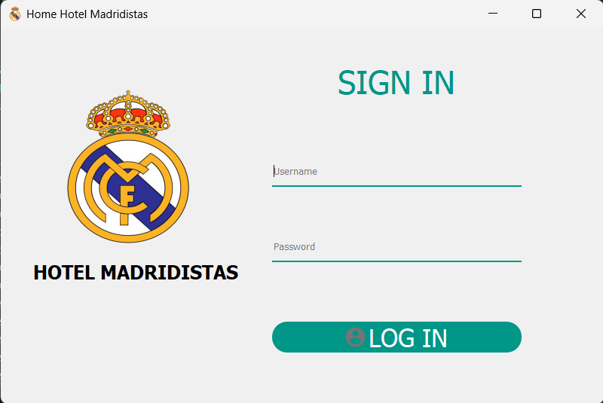

### b) Deskripsi Form Login

Form ini berfungsi untuk masuk user yang sudah ada pada database aplikasi dan juga masuk aplikasi. Dengan menggunakan tombol login untuk masuk ke aplikasi yakni hrefke tampilan main menu

### c) Detai Aplikasi

* Tabel komponen Visual, Text dan Variabel

|  |  |  |
| --- | --- | --- |
| Komponen Visual | Text | Variabel |
| Self.username | Username | Username |
| Self.password | Password | Password |
| Self.buttonLogIn | Login | - |

* Source Code
  + Tombol Login

|  |
| --- |
| Buat tampilan tombol  Source file: MainApp.py  Source class: Ui_LogInMenu  self.ButtonLogIn = QtWidgets.QPushButton(LogInMenu)          self.ButtonLogIn.setGeometry(QtCore.QRect(360, 390, 331, 41))          font = QtGui.QFont()          font.setFamily("Sans Serif")          font.setPointSize(20)          self.ButtonLogIn.setFont(font)   self.ButtonLogIn.setCursor(QtGui.QCursor(QtCore.Qt.PointingHandCursor))          self.ButtonLogIn.setStyleSheet("QPushButton{\n"  "background-color: rgb(0, 150, 136);\n"  "color:white;\n"  "border-style:outset;\n"  "border-radius:20px;\n"  "}\n"  "QPushButton::hover{\n"  "background-color: rgb(255, 255, 255);\n"  "color:black;\n"  "border-style:outset;\n"  "border-width:2px;\n"  "border-radius:20px;\n"  "border-color:rgb(0,150,136);\n"  "}")   icon1 = QtGui.QIcon()   icon1.addPixmap(QtGui.QPixmap("C:\\Users\\shafira\\Documents\\New folder\\project pbo\\fix\\img/akun.png"), QtGui.QIcon.Normal, QtGui.QIcon.Off)          self.ButtonLogIn.setIcon(icon1)          self.ButtonLogIn.setIconSize(QtCore.QSize(31, 31))          self.ButtonLogIn.setObjectName("ButtonLogIn")          self.ButtonLogIn.clicked.connect(self.LogInClicked) |
| Fungsi tombol  Source file: MainApp.py  Source class: Ui_LogInMenu  def LogInClicked(self):          _translate = QtCore.QCoreApplication.translate          cursor = self.db.cursor()          infoAdmin = ("SELECT `username`, `password` FROM Admin")          cursor.execute(infoAdmin)          infoUser = False          infoPass = False          for (username, password) in cursor:              if self.username.text() == username:                  infoUser = True              if self.password.text() == password:                  infoPass = True            if infoPass == True and infoUser == True:              self.openMainWindow()          elif infoUser == False:              self.EHUsername.setText(_translate("LogInMenu", "<font color=\"red\">Username anda salah</font>"))              self.EHPassword.setText(_translate("LogInMenu", "<font color=\"red\">Password anda salah</font>"))          else :              self.EHUsername.setText(_translate("LogInMenu", "<font color=\"red\"> </font>"))              self.EHPassword.setText(_translate("LogInMenu", "<font color=\"red\">Password anda salah</font>")) |

## 2. Form Transaksi

### A. Booking Kamar

Nama Form: Booking

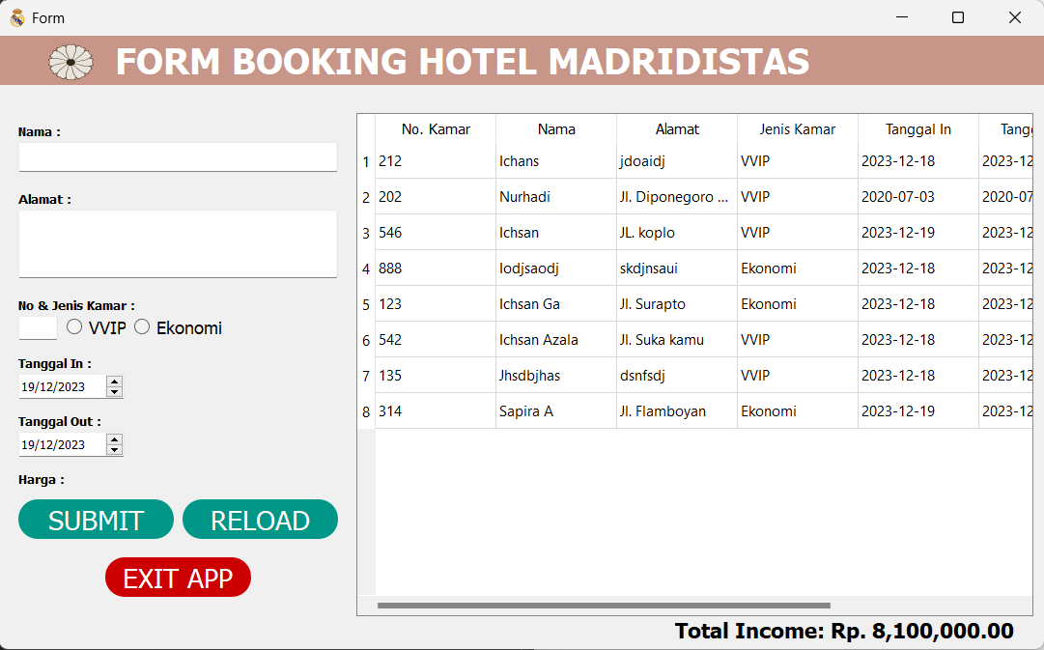

Deskripsi

Form ini berfungsi sebagai transaksi pemesanan kamar dan juga pengolahan data berupa penjumlahan harga yang harus dibayarkan oleh pelanggan. Dengan menggunakan tombol submit untuk melakukan input data dan tombol reload untuk mereload atau refresh tampilan dashboard

Detail Aplikasi

* Komponen Visual, Text dan Variabel

|  |  |  |
| --- | --- | --- |
| Komponen Visual | Text | Variabel |
| Self.labelnama | Kosongkan | Nama |
| Self.lineAlamat | Kosongkan | Alamat |
| Self.labelkamar | Kosongkan | No. Kamar |
| Self.radioEkonomi | Kosongkan | Ekonomi |
| Self.radioVVIP | Kosongkan | VVIP |
| Self.dateIn | Date time now | TanggalIn |
| Self.dateOut | Date time now | TanggalOut |
| Self.fromharga | Harga | Harga |
| Self.BtnEdit | Submit | Submit |
| Self.BtnReload | Reload | Reload |
| Self.BtnExit | Exit App | Exit |

* Source Code

1. Tombol Submit

|  |
| --- |
| Buat tampilan tombol  Source file: MenuBooking.py  Source class: Ui_Booking  self.BtnEdit = QtWidgets.QPushButton(Form)          self.BtnEdit.setGeometry(QtCore.QRect(20, 480, 161, 41))          font = QtGui.QFont()          font.setFamily("Sans Serif")          font.setPointSize(17)          font.setBold(False)          font.setWeight(50)          self.BtnEdit.setFont(font)          self.BtnEdit.setCursor(QtGui.QCursor(QtCore.Qt.PointingHandCursor))          self.BtnEdit.setStyleSheet("QPushButton{\n"  "background-color: rgb(0, 150, 136);\n"  "color:white;\n"  "border-style:outset;\n"  "border-radius:20px;\n"  "}\n"  "QPushButton::hover{\n"  "background-color: rgb(255, 255, 255);\n"  "color:black;\n"  "border-style:outset;\n"  "border-width:2px;\n"  "border-radius:20px;\n"  "border-color:rgb(0,150,136);\n"  "}")          self.BtnEdit.setObjectName("BtnEdit")          self.BtnEdit.clicked.connect(self.clickedSubmit) |
| Fungsi tombol  Source file: MenuBooking.py  Source class: Ui_Booking  def clickedSubmit(self):          db = mysql.connector.connect(user="root", database="Hotel")          cursor = db.cursor()          conn = pymysql.connect(user="root", db="Hotel", autocommit=True)          cur = conn.cursor()          DateIn = self.DateIn.date().toString("yyyy-MM-dd")          formatted_date_in = datetime.datetime.strptime(DateIn, "%Y-%m-%d").date()          DateOut = self.DateOut.date().toString("yyyy-MM-dd")          formatted_date_out = datetime.datetime.strptime(DateOut, "%Y-%m-%d").date()          # Extracting dates from the date edit widgets          date_in = self.DateIn.date().toPyDate()          date_out = self.DateOut.date().toPyDate()          # Calculating the number of days          num_days = (date_out - date_in).days            id_tamu = 0          id_transaksi = 0          query1 = ("SELECT `Tamu`.`id_tamu`, `Transaksi`.`id_transaksi` FROM Transaksi, Tamu WHERE Tamu.id_tamu = Transaksi.id_tamuFK")          cursor.execute(query1)          for (dataTamu, dataTransaksi) in cursor:              id_tamu = int(dataTamu)              id_transaksi = int(dataTransaksi)          harga = 0          if self.infoRadio == "Ekonomi":              harga = 300000          else :              harga = 400000          total_cost = harga * num_days          query2 = ("INSERT INTO Tamu(id_tamu, nama_tamu, alamat) VALUES(%s, %s, %s)")          cur.execute(query2, (id_tamu+1, self.FormNama.text(), self.LineAlamat.text()))          query3 = ("INSERT INTO Kamar(no_kamar, id_tamuFK, jenis_kamar) VALUES(%s, %s, %s)")          cur.execute(query3, (self.FormNoKamar.text(), id_tamu+1, self.infoRadio))          query4 = ("INSERT INTO Transaksi(id_transaksi, id_tamuFK, no_kamarFK, tanggal_in, tanggal_out, jumlah) VALUES(%s, %s, %s, %s, %s, %s)")          cur.execute(query4, (id_transaksi+1, id_tamu+1, self.FormNoKamar.text(), formatted_date_in, formatted_date_out, total_cost))          db.commit()          cursor.close()          cur.close()          conn.close()          db.close()          self.ReloadData()          self.show_message("Submit Tamu", f"Data tamu sudah tersubmit. Total cost: Rp. {total_cost:,.2f}") |

1. Tombol reload

|  |
| --- |
| Tampilan Tombol  Source file: MenuBooking.py  Source class: Ui_Booking  self.BtnReload = QtWidgets.QPushButton(Form)          self.BtnReload.setGeometry(QtCore.QRect(190, 480, 161, 41))          font = QtGui.QFont()          font.setFamily("Sans Serif")          font.setPointSize(17)          font.setBold(False)          font.setWeight(50)          self.BtnReload.setFont(font)          self.BtnReload.setCursor(QtGui.QCursor(QtCore.Qt.PointingHandCursor))          self.BtnReload.setStyleSheet("QPushButton{\n"  "background-color: rgb(0, 150, 136);\n"  "color:white;\n"  "border-style:outset;\n"  "border-radius:20px;\n"  "}\n"  "QPushButton::hover{\n"  "background-color: rgb(255, 255, 255);\n"  "color:black;\n"  "border-style:outset;\n"  "border-width:2px;\n"  "border-radius:20px;\n"  "border-color:rgb(0,150,136);\n"  "}")          self.BtnReload.setObjectName("BtnReload")          self.BtnReload.clicked.connect(self.clickedReload) |
| Fungsi Tombol  Source file: MenuBooking.py  Source class: Ui_Booking  def ReloadData(self):          db = mysql.connector.connect(user="root", database="Hotel")          cursor = db.cursor()          query = ("SELECT `Kamar`.`no_kamar`, `Tamu`.`nama_tamu`, `Tamu`.`alamat`, `Kamar`.`jenis_kamar`, `Transaksi`.`tanggal_in`, `Transaksi`.`tanggal_out`, `Transaksi`.`jumlah` FROM Transaksi, Kamar, Tamu WHERE Kamar.no_kamar = Transaksi.no_kamarFK AND Tamu.id_tamu = Transaksi.id_tamuFK")          cursor.execute(query)          self.TableInform.setRowCount(0)          for row_number, row_data in enumerate(cursor):              self.TableInform.insertRow(row_number)              for colum_number, data in enumerate(row_data):                  self.TableInform.setItem(row_number, colum_number, QtWidgets.QTableWidgetItem(str(data)))          total_income = self.calculate_total_income()  # Add this line          self.LabelTotalIncome.setText(f"Total Income: Rp. {total_income:,.2f}")  # Update this line          db.commit()          cursor.close()          db.close() |

1. Tombol Exit App

|  |
| --- |
| Tampilan Tombol  Source file: MenuBooking.py  Source class: Ui_Booking  self.BtnExit = QtWidgets.QPushButton(Form)          self.BtnExit.setGeometry(QtCore.QRect(110, 540, 151, 41))          font = QtGui.QFont()          font.setPointSize(17)          self.BtnExit.setFont(font)          self.BtnExit.setCursor(QtGui.QCursor(QtCore.Qt.PointingHandCursor))          self.BtnExit.setStyleSheet("QPushButton{\n"  "background-color: rgb(204, 0, 0);\n"  "color:white;\n"  "border-style:outset;\n"  "border-radius:20px;\n"  "}\n"  "QPushButton::hover{\n"  "background-color: rgb(255, 255, 255);\n"  "color:black;\n"  "border-style:outset;\n"  "border-width:2px;\n"  "border-radius:20px;\n"  "border-color:rgb(204, 0, 0);\n"  "}")          self.BtnExit.setObjectName("BtnExit")          self.BtnExit.clicked.connect(self.ClickedExit) |
| Fungsi Tombol  Source file: MenuBooking.py  Source class: Ui_Booking  def ClickedExit(self):          msg = QtWidgets.QMessageBox()          msg.setWindowTitle("Exit Aplication")          msg.setText("Are you sure exit?")          msg.setIcon(QtWidgets.QMessageBox.Question)          msg.setStandardButtons(QtWidgets.QMessageBox.Cancel | QtWidgets.QMessageBox.Yes)          msg.setDefaultButton(QtWidgets.QMessageBox.Cancel)          msg.buttonClicked.connect(self.LogOut)          x = msg.exec_() |

### B. Edit / Update

1. Nama Form: Edit

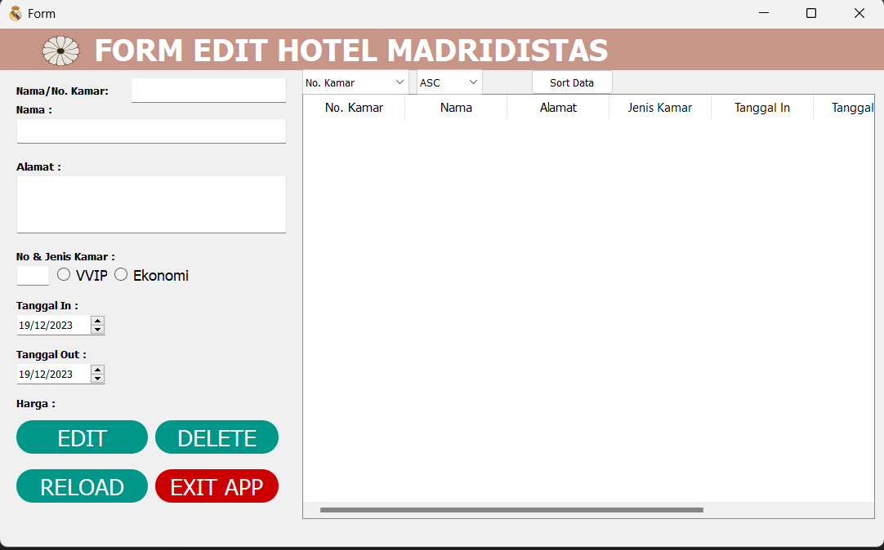

1. Deskripsi

Form ini berfungsi sebagai transaksi pengeditan pemesanan kamar dan juga update dari pengolahan data berupa penjumlahan harga yang harus dibayarkan oleh pelanggan yang telah di edit. Dengan menggunakan tombol submit untuk melakukan input data, tombol reload untuk mereload atau refresh tampilan dashboard dan delete untuk menghapus data

1. Detail Aplikasi

* Komponen Visual, Text dan Variabel

|  |  |  |
| --- | --- | --- |
| Komponen Visual | Text | Variabel |
| Self.labelnama | Kosongkan | Nama |
| Self.lineAlamat | Kosongkan | Alamat |
| Self.labelkamar | Kosongkan | No. Kamar |
| Self.radioEkonomi | Kosongkan | Ekonomi |
| Self.radioVVIP | Kosongkan | VVIP |
| Self.dateIn | Date time now | TanggalIn |
| Self.dateOut | Date time now | TanggalOut |
| Self.fromharga | Harga | Harga |
| Self.BtnEdit | Submit | Submit |
| Self.BtnReload | Reload | Reload |
| Self.BtnExit | Exit App | Exit |
| Self.lebelSearch | No. Kamar | Search |
| Self.ComboBoxSortBy | No. Kamar", "Nama", "Tanggal In", "Tanggal Out” | Item |
| Self.ComboBoxSortOrder | “ASC”, “DESC” | Item |
| Self.BtnSort | Cari | - |

* Source Code

Tombol Submit

|  |
| --- |
| Buat tampilan tombol  Source file: MenuEdit.py  Source class: Ui_Edit  self.BtnEdit = QtWidgets.QPushButton(Form)          self.BtnEdit.setGeometry(QtCore.QRect(20, 480, 161, 41))          font = QtGui.QFont()          font.setFamily("Sans Serif")          font.setPointSize(17)          font.setBold(False)          font.setWeight(50)          self.BtnEdit.setFont(font)          self.BtnEdit.setCursor(QtGui.QCursor(QtCore.Qt.PointingHandCursor))          self.BtnEdit.setStyleSheet("QPushButton{\n"  "background-color: rgb(0, 150, 136);\n"  "color:white;\n"  "border-style:outset;\n"  "border-radius:20px;\n"  "}\n"  "QPushButton::hover{\n"  "background-color: rgb(255, 255, 255);\n"  "color:black;\n"  "border-style:outset;\n"  "border-width:2px;\n"  "border-radius:20px;\n"  "border-color:rgb(0,150,136);\n"  "}")          self.BtnEdit.setObjectName("BtnEdit")          self.BtnEdit.clicked.connect(self.clickedSubmit) |
| Fungsi tombol  Source file: MenuEdit.py  Source class: Ui_Edit  def clickedSubmit(self):          db = mysql.connector.connect(user="root", database="Hotel")          cursor = db.cursor()          conn = pymysql.connect(user="root", db="Hotel", autocommit=True)          cur = conn.cursor()          DateIn = self.DateIn.date().toString("yyyy-MM-dd")          formatted_date_in = datetime.datetime.strptime(DateIn, "%Y-%m-%d").date()          DateOut = self.DateOut.date().toString("yyyy-MM-dd")          formatted_date_out = datetime.datetime.strptime(DateOut, "%Y-%m-%d").date()          # Extracting dates from the date edit widgets          date_in = self.DateIn.date().toPyDate()          date_out = self.DateOut.date().toPyDate()          # Calculating the number of days          num_days = (date_out - date_in).days            id_tamu = 0          id_transaksi = 0          query1 = ("SELECT `Tamu`.`id_tamu`, `Transaksi`.`id_transaksi` FROM Transaksi, Tamu WHERE Tamu.id_tamu = Transaksi.id_tamuFK")          cursor.execute(query1)          for (dataTamu, dataTransaksi) in cursor:              id_tamu = int(dataTamu)              id_transaksi = int(dataTransaksi)          harga = 0          if self.infoRadio == "Ekonomi":              harga = 300000          else :              harga = 400000          total_cost = harga * num_days          query2 = ("INSERT INTO Tamu(id_tamu, nama_tamu, alamat) VALUES(%s, %s, %s)")          cur.execute(query2, (id_tamu+1, self.FormNama.text(), self.LineAlamat.text()))          query3 = ("INSERT INTO Kamar(no_kamar, id_tamuFK, jenis_kamar) VALUES(%s, %s, %s)")          cur.execute(query3, (self.FormNoKamar.text(), id_tamu+1, self.infoRadio))          query4 = ("INSERT INTO Transaksi(id_transaksi, id_tamuFK, no_kamarFK, tanggal_in, tanggal_out, jumlah) VALUES(%s, %s, %s, %s, %s, %s)")          cur.execute(query4, (id_transaksi+1, id_tamu+1, self.FormNoKamar.text(), formatted_date_in, formatted_date_out, total_cost))          db.commit()          cursor.close()          cur.close()          conn.close()          db.close()          self.ReloadData()          self.show_message("Submit Tamu", f"Data tamu sudah tersubmit. Total cost: Rp. {total_cost:,.2f}") |

Tombol reload

|  |
| --- |
| Tampilan Tombol  Source file: MenuEdit.py  Source class: Ui_Edit  self.BtnReload = QtWidgets.QPushButton(Form)          self.BtnReload.setGeometry(QtCore.QRect(190, 480, 161, 41))          font = QtGui.QFont()          font.setFamily("Sans Serif")          font.setPointSize(17)          font.setBold(False)          font.setWeight(50)          self.BtnReload.setFont(font)          self.BtnReload.setCursor(QtGui.QCursor(QtCore.Qt.PointingHandCursor))          self.BtnReload.setStyleSheet("QPushButton{\n"  "background-color: rgb(0, 150, 136);\n"  "color:white;\n"  "border-style:outset;\n"  "border-radius:20px;\n"  "}\n"  "QPushButton::hover{\n"  "background-color: rgb(255, 255, 255);\n"  "color:black;\n"  "border-style:outset;\n"  "border-width:2px;\n"  "border-radius:20px;\n"  "border-color:rgb(0,150,136);\n"  "}")          self.BtnReload.setObjectName("BtnReload")          self.BtnReload.clicked.connect(self.clickedReload) |
| Fungsi Tombol  Source file: MenuEdit.py  Source class: Ui_Edit  def ReloadData(self):          db = mysql.connector.connect(user="root", database="Hotel")          cursor = db.cursor()          query = ("SELECT `Kamar`.`no_kamar`, `Tamu`.`nama_tamu`, `Tamu`.`alamat`, `Kamar`.`jenis_kamar`, `Transaksi`.`tanggal_in`, `Transaksi`.`tanggal_out`, `Transaksi`.`jumlah` FROM Transaksi, Kamar, Tamu WHERE Kamar.no_kamar = Transaksi.no_kamarFK AND Tamu.id_tamu = Transaksi.id_tamuFK")          cursor.execute(query)          self.TableInform.setRowCount(0)          for row_number, row_data in enumerate(cursor):              self.TableInform.insertRow(row_number)              for colum_number, data in enumerate(row_data):                  self.TableInform.setItem(row_number, colum_number, QtWidgets.QTableWidgetItem(str(data)))          total_income = self.calculate_total_income()  # Add this line          self.LabelTotalIncome.setText(f"Total Income: Rp. {total_income:,.2f}")  # Update this line          db.commit()          cursor.close()          db.close() |

Tombol Exit App

|  |
| --- |
| Tampilan Tombol  Source file: MenuEdit.py  Source class: Ui_Edit  self.BtnExit = QtWidgets.QPushButton(Form)          self.BtnExit.setGeometry(QtCore.QRect(110, 540, 151, 41))          font = QtGui.QFont()          font.setPointSize(17)          self.BtnExit.setFont(font)          self.BtnExit.setCursor(QtGui.QCursor(QtCore.Qt.PointingHandCursor))          self.BtnExit.setStyleSheet("QPushButton{\n"  "background-color: rgb(204, 0, 0);\n"  "color:white;\n"  "border-style:outset;\n"  "border-radius:20px;\n"  "}\n"  "QPushButton::hover{\n"  "background-color: rgb(255, 255, 255);\n"  "color:black;\n"  "border-style:outset;\n"  "border-width:2px;\n"  "border-radius:20px;\n"  "border-color:rgb(204, 0, 0);\n"  "}")          self.BtnExit.setObjectName("BtnExit")          self.BtnExit.clicked.connect(self.ClickedExit) |
| Fungsi Tombol  Source file: MenuEdit.py  Source class: Ui_Edit  def ClickedExit(self):          msg = QtWidgets.QMessageBox()          msg.setWindowTitle("Exit Aplication")          msg.setText("Are you sure exit?")          msg.setIcon(QtWidgets.QMessageBox.Question)          msg.setStandardButtons(QtWidgets.QMessageBox.Cancel | QtWidgets.QMessageBox.Yes)          msg.setDefaultButton(QtWidgets.QMessageBox.Cancel)          msg.buttonClicked.connect(self.LogOut)          x = msg.exec_() |

1. Tombol Delete

|  |
| --- |
| Buat Tampilan Tombol  Source file: MenuEdit.py  Source class: Ui_Edit  self.BtnDelete = QtWidgets.QPushButton(Form)          self.BtnDelete.setGeometry(QtCore.QRect(190, 480, 151, 41))          font = QtGui.QFont()          font.setPointSize(17)          self.BtnDelete.setFont(font)          self.BtnDelete.setCursor(QtGui.QCursor(QtCore.Qt.PointingHandCursor))          self.BtnDelete.setStyleSheet("QPushButton{\n"  "background-color: rgb(0, 150, 136);\n"  "color:white;\n"  "border-style:outset;\n"  "border-radius:20px;\n"  "}\n"  "QPushButton::hover{\n"  "background-color: rgb(204, 0, 0);\n"  "color:white;\n"  "border-style:outset;\n"  "border-width:2px;\n"  "border-radius:20px;\n"  "border-color:rgb(0, 150, 136);\n"  "}")          self.BtnDelete.setObjectName("BtnDelete")          self.BtnDelete.clicked.connect(self.ClickedDelete) |
| Fungsi Tombol  Source file: MenuEdit.py  Source class: Ui_Edit  def ClickedDelete(self):          msg = QtWidgets.QMessageBox()          msg.setWindowTitle("Delete Data")          msg.setText("Are you sure delete this data?")          msg.setIcon(QtWidgets.QMessageBox.Question)          msg.setStandardButtons(QtWidgets.QMessageBox.Cancel | QtWidgets.QMessageBox.Yes)          msg.setDefaultButton(QtWidgets.QMessageBox.Cancel)          msg.buttonClicked.connect(self.DeleteData)          x = msg.exec_()      def DeleteData(self, i):          if i.text() == "&Yes":              conn = pymysql.connect(user="root", db="Hotel", autocommit=True)              cursor = conn.cursor()              query = ("SELECT id_transaksi, id_tamuFK, no_kamarFK FROM Transaksi WHERE no_kamarFK = %s")              cursor.execute(query, self.SelectedItems())              id_transaksi = 0              id_tamu = 0              id_kamar = 0              for (id_data1, id_data2, id_data3) in cursor:                  id_transaksi = int(id_data1)                  id_tamu = int(id_data2)                  id_kamar = int(id_data3)              query2 = ("DELETE FROM Transaksi WHERE id_transaksi = %s")              cursor.execute(query2, id_transaksi)              query3 = ("DELETE FROM Tamu WHERE id_tamu = %s")              cursor.execute(query3, id_tamu)              query4 = ("DELETE FROM Kamar WHERE no_kamar = %s")              cursor.execute(query4, id_kamar)              cursor.close()              conn.close()              self.ReloadData() |

1. Tombol Cari

|  |
| --- |
| Buat Tampilan Tombol  Source file: MenuEdit.py  Source class: Ui_Edit  self.BtnSort = QtWidgets.QPushButton(Form)          self.BtnSort.setGeometry(QtCore.QRect(650, 50, 101, 31))          self.BtnSort.setObjectName("BtnSort")          self.BtnSort.setText("Cari")          self.BtnSort.clicked.connect(self.SortData) |
| Fungsi Tombol  Source file: MenuEdit.py  Source class: Ui_Edit  def SortData(self):          sort_column = self.ComboBoxSortBy.currentText()          sort_order = self.ComboBoxSortOrder.currentText()          # Perform sorting based on selected criteria          self.BubbleSort(sort_column, sort_order)  def BubbleSort(self, sort_column, sort_order):          rows = self.TableInform.rowCount()          cols = self.TableInform.columnCount()          data = [[self.TableInform.item(row, col).text() for col in range(cols)] for row in range(rows)]          # Get the column index for sorting          column_index = self.get_column_index(sort_column)          # Bubble Sort Implementation          for i in range(rows - 1):              for j in range(0, rows - i - 1):                  if (sort_order == "ASC" and data[j][column_index] > data[j + 1][column_index]) or \                          (sort_order == "DESC" and data[j][column_index] < data[j + 1][column_index]):                      data[j], data[j + 1] = data[j + 1], data[j]          # Update the table after sorting          for row in range(rows):              for col in range(cols):                  self.TableInform.setItem(row, col, QtWidgets.QTableWidgetItem(str(data[row][col]))) |

1. Sorting by

|  |
| --- |
| Buat Tampilan  Source file: MenuEdit.py  Source class: Ui_Edit  self.ComboBoxSortBy = QtWidgets.QComboBox(Form)          self.ComboBoxSortBy.setGeometry(QtCore.QRect(370, 50, 131, 31))          self.ComboBoxSortBy.setObjectName("ComboBoxSortBy")          self.ComboBoxSortBy.addItems(["No. Kamar", "Nama", "Tanggal In", "Tanggal Out"]) |

1. Sorting order

|  |
| --- |
| Buat Tampilan  Source file: MenuEdit.py  Source class: Ui_Edit  self.ComboBoxSortOrder = QtWidgets.QComboBox(Form)          self.ComboBoxSortOrder.setGeometry(QtCore.QRect(510, 50, 81, 31))          self.ComboBoxSortOrder.setObjectName("ComboBoxSortOrder")          self.ComboBoxSortOrder.addItems(["ASC", "DESC"]) |

## 3.Form Chek In/Out

### a) Tampilan

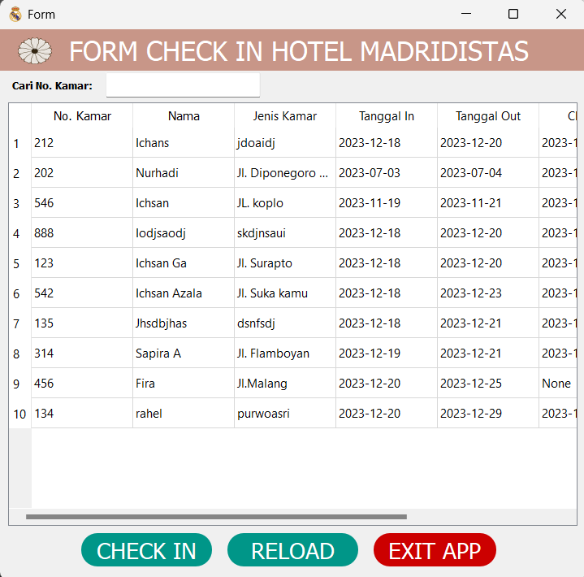

### b)Deskripsi Form Check In/Out

Form ini berfungsi untuk check in/out pesanan yang menandakan bahwa memulai / Mengakhiri durasi waktu sewa sudah habis. Dengan menggunakan tombol check in/out untuk mencatat bahwa kamar telah di pakai atau sedang ada orang di dalam nya.

### c)Detail Check in/out

* Komponen Visual, Text, dan Variable

|  |  |  |
| --- | --- | --- |
| Komponen Visual | Text | Variable |
| Self.labelsearch | Cari No.Kamar | - |
| Self.BtnEdit_2 | Check In | - |
| Self.BtnDelete | Exit App | - |
| Self.BtnReload | Reload | - |

* Source Code

1. Label search

|  |
| --- |
| Source file: MenuCheckIn.py  Source class: Ui_ChekIn  self.LabelSearch = QtWidgets.QLabel(Form)          self.LabelSearch.setGeometry(QtCore.QRect(15, 53, 131, 31))          font = QtGui.QFont()          font.setFamily("Sans Serif")          font.setBold(True)          font.setWeight(75)          self.LabelSearch.setFont(font)          self.LabelSearch.setObjectName("LabelSearch")          self.LabelSearch.setText("Cari No. Kamar:") |

1. Tombol Chek In

|  |
| --- |
| Buat Tampilan  Source file: MenuCheckIn.py  Source class: Ui_ChekIn  self.BtnEdit_2 = QtWidgets.QPushButton(Form)          self.BtnEdit_2.setGeometry(QtCore.QRect(100, 620, 161, 41))          font = QtGui.QFont()          font.setFamily("Sans Serif")          font.setPointSize(17)          font.setBold(False)          font.setWeight(50)          self.BtnEdit_2.setFont(font)          self.BtnEdit_2.setCursor(QtGui.QCursor(QtCore.Qt.PointingHandCursor))          self.BtnEdit_2.setStyleSheet("QPushButton{\n"  "background-color: rgb(0, 150, 136);\n"  "color:white;\n"  "border-style:outset;\n"  "border-radius:20px;\n"  "}\n"  "QPushButton::hover{\n"  "background-color: rgb(255, 255, 255);\n"  "color:black;\n"  "border-style:outset;\n"  "border-width:2px;\n"  "border-radius:20px;\n"  "border-color:rgb(0,150,136);\n"  "}")          self.BtnEdit_2.setObjectName("BtnEdit_2")          self.BtnEdit_2.clicked.connect(self.ClickedCheckIn) |
| Fungsi Tombol  Source file: MenuCheckIn.py  Source class: Ui_ChekIn  def ClickedCheckIn(self):          conn = pymysql.connect(user="root", db="Hotel", autocommit=True)          cursor = conn.cursor()          Date = datetime.datetime.now()          Year = str(Date.year)          Month = str(Date.month)          Day = str(Date.day)          equery = ("UPDATE Transaksi SET check_in = %s WHERE no_kamarFK = %s")          cursor.execute(equery, (Year+"-"+Month+"-"+Day, self.SelectedItems()))          cursor.close()          conn.close()          self.ReloadData()          self.show_message("Check In", "Check In Selesai") |

1. Tombol reload

|  |
| --- |
| Tampilan Tombol  Source file: MenuCheckIn.py  Source class: Ui_ChekIn  self.BtnReload = QtWidgets.QPushButton(Form)          self.BtnReload.setGeometry(QtCore.QRect(190, 480, 161, 41))          font = QtGui.QFont()          font.setFamily("Sans Serif")          font.setPointSize(17)          font.setBold(False)          font.setWeight(50)          self.BtnReload.setFont(font)          self.BtnReload.setCursor(QtGui.QCursor(QtCore.Qt.PointingHandCursor))          self.BtnReload.setStyleSheet("QPushButton{\n"  "background-color: rgb(0, 150, 136);\n"  "color:white;\n"  "border-style:outset;\n"  "border-radius:20px;\n"  "}\n"  "QPushButton::hover{\n"  "background-color: rgb(255, 255, 255);\n"  "color:black;\n"  "border-style:outset;\n"  "border-width:2px;\n"  "border-radius:20px;\n"  "border-color:rgb(0,150,136);\n"  "}")          self.BtnReload.setObjectName("BtnReload")          self.BtnReload.clicked.connect(self.clickedReload) |
| Fungsi Tombol  Source file: MenuCheckIn.py  Source class: Ui_ChekIn  def ReloadData(self):          db = mysql.connector.connect(user="root", database="Hotel")          cursor = db.cursor()          query = ("SELECT `Kamar`.`no_kamar`, `Tamu`.`nama_tamu`, `Tamu`.`alamat`, `Kamar`.`jenis_kamar`, `Transaksi`.`tanggal_in`, `Transaksi`.`tanggal_out`, `Transaksi`.`jumlah` FROM Transaksi, Kamar, Tamu WHERE Kamar.no_kamar = Transaksi.no_kamarFK AND Tamu.id_tamu = Transaksi.id_tamuFK")          cursor.execute(query)          self.TableInform.setRowCount(0)          for row_number, row_data in enumerate(cursor):              self.TableInform.insertRow(row_number)              for colum_number, data in enumerate(row_data):                  self.TableInform.setItem(row_number, colum_number, QtWidgets.QTableWidgetItem(str(data)))          total_income = self.calculate_total_income()  # Add this line          self.LabelTotalIncome.setText(f"Total Income: Rp. {total_income:,.2f}")  # Update this line          db.commit()          cursor.close()          db.close() |

1. Tombol Exit app

|  |
| --- |
| Tampilan Tombol  Source file: MenuCheckIn.py  Source class: Ui_ChekIn  self.BtnExit = QtWidgets.QPushButton(Form)          self.BtnExit.setGeometry(QtCore.QRect(110, 540, 151, 41))          font = QtGui.QFont()          font.setPointSize(17)          self.BtnExit.setFont(font)          self.BtnExit.setCursor(QtGui.QCursor(QtCore.Qt.PointingHandCursor))          self.BtnExit.setStyleSheet("QPushButton{\n"  "background-color: rgb(204, 0, 0);\n"  "color:white;\n"  "border-style:outset;\n"  "border-radius:20px;\n"  "}\n"  "QPushButton::hover{\n"  "background-color: rgb(255, 255, 255);\n"  "color:black;\n"  "border-style:outset;\n"  "border-width:2px;\n"  "border-radius:20px;\n"  "border-color:rgb(204, 0, 0);\n"  "}")          self.BtnExit.setObjectName("BtnExit")          self.BtnExit.clicked.connect(self.ClickedExit) |
| Fungsi Tombol  Source file: MenuCheckIn.py  Source class: Ui_ChekIn  def ClickedExit(self):          msg = QtWidgets.QMessageBox()          msg.setWindowTitle("Exit Aplication")          msg.setText("Are you sure exit?")          msg.setIcon(QtWidgets.QMessageBox.Question)          msg.setStandardButtons(QtWidgets.QMessageBox.Cancel | QtWidgets.QMessageBox.Yes)          msg.setDefaultButton(QtWidgets.QMessageBox.Cancel)          msg.buttonClicked.connect(self.LogOut)          x = msg.exec_() |

## 4.Income / Laporan keuangan perbulan

### a) Tampilan

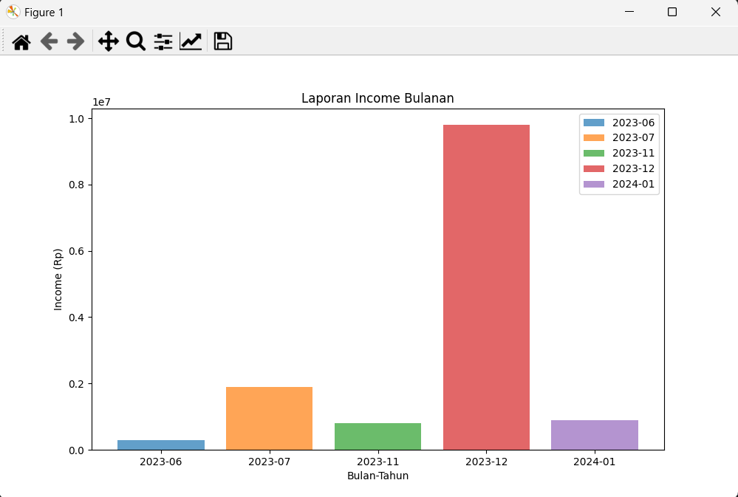

### b) Komponen Visual, Text dan Variabel

|  |  |  |
| --- | --- | --- |
| Komponen Visual | Text | Variabel |
| ax.set_xlabel | Bulan | - |
| ax.set_ylabel | Income | - |
| ax.set_title | Laporan Income Bulanan | - |

### c) Source Code

1. Tampilan form

|  |
| --- |
| Source file: income.py  Source class: LaporanIncome  def __init__(self):          super(LaporanIncome, self).__init__()          self.central_widget = QWidget(self)          self.setCentralWidget(self.central_widget)          self.layout = QVBoxLayout(self.central_widget)          self.canvas = FigureCanvas(Figure(figsize=(10, 6)))          self.layout.addWidget(self.canvas)          self.setWindowTitle('Income Bulanan') |

1. Gambar grafik

|  |
| --- |
| Source file: income.py  Source class: LaporanIncome  def plot_monthly_income(self):          import matplotlib.pyplot as plt          # Fetch monthly income data from the database          monthly_income_data = self.fetch_monthly_income()          # Extract years, months, and income from the data          years_months_income = {entry[:2]: entry[2] for entry in monthly_income_data}          # Plotting          fig, ax = plt.subplots(figsize=(10, 6))          for (year, month), income in years_months_income.items():              ax.bar(f"{year}-{month:02d}", income, label=f"{year}-{month:02d}", alpha=0.7)          ax.set_xlabel('Bulan-Tahun')          ax.set_ylabel('Income (Rp)')          ax.set_title('Laporan Income Bulanan')          ax.legend()          # Display the plot          self.canvas.figure = fig          self.canvas.draw()          # Start Matplotlib event loop          plt.show(block=False)  Data Query  def fetch_monthly_income(self):          db = mysql.connector.connect(user="root", database="Hotel")          cursor = db.cursor()          query = """                  SELECT YEAR(tanggal_in) AS year, MONTH(tanggal_in) AS month, SUM(jumlah) AS total_income                  FROM Transaksi                  GROUP BY YEAR(tanggal_in), MONTH(tanggal_in)                  """          cursor.execute(query)          monthly_income_data = cursor.fetchall()          db.commit()          cursor.close()          db.close()          return monthly_income_data |

# QUERY

## Menampilkan form

### Booking

|  |
| --- |
| Source file: MenuBooking.py  Source class: Ui_Booking  SELECT  `Kamar`.`no_kamar`,  `Tamu`.`nama_tamu`,  `Tamu`.`alamat`,  `Kamar`.`jenis_kamar`,  `Transaksi`.`tanggal_in`,  `Transaksi`.`tanggal_out`,  `Transaksi`.`jumlah`  FROM  Transaksi, Kamar, Tamu  WHERE  Kamar.no_kamar = Transaksi.no_kamarFK AND Tamu.id_tamu = Transaksi.id_tamuFK; |

### Edit

|  |
| --- |
| Source file: MenuEdit.py  Source class: Ui_Edit  SELECT  `Kamar`.`no_kamar`,  `Tamu`.`nama_tamu`,  `Tamu`.`alamat`,  `Kamar`.`jenis_kamar`,  `Transaksi`.`tanggal_in`,  `Transaksi`.`tanggal_out`,  `Transaksi`.`jumlah`  FROM  Transaksi, Kamar, Tamu  WHERE  Kamar.no_kamar = Transaksi.no_kamarFK AND Tamu.id_tamu = Transaksi.id_tamuFK; |

### Check In/Out

|  |
| --- |
| Source file: MenuCheckIn.py  Source class: Ui_CheckIn  query = ("SELECT `Kamar`.`no_kamar`, `Tamu`.`nama_tamu`, `Tamu`.`alamat`, `Transaksi`.`tanggal_in`, `Transaksi`.`tanggal_out`, `Transaksi`.`check_in`, `Transaksi`.check_out FROM Transaksi, Kamar, Tamu WHERE Kamar.no_kamar = Transaksi.no_kamarFK AND Tamu.id_tamu = Transaksi.id_tamuFK") |

## Fungsi tombol

### Submit booking

|  |
| --- |
| Source file: MenuBooking.py  Source class: Ui_Booking  query1 = ("SELECT `Tamu`.`id_tamu`, `Transaksi`.`id_transaksi` FROM Transaksi, Tamu WHERE Tamu.id_tamu = Transaksi.id_tamuFK")          cursor.execute(query1)          for (dataTamu, dataTransaksi) in cursor:              id_tamu = int(dataTamu)              id_transaksi = int(dataTransaksi)          harga = 0          if self.infoRadio == "Ekonomi":              harga = 300000          else :              harga = 400000          total_cost = harga * num_days          query2 = ("INSERT INTO Tamu(id_tamu, nama_tamu, alamat) VALUES(%s, %s, %s)")          cur.execute(query2, (id_tamu+1, self.FormNama.text(), self.LineAlamat.text()))          query3 = ("INSERT INTO Kamar(no_kamar, id_tamuFK, jenis_kamar) VALUES(%s, %s, %s)")          cur.execute(query3, (self.FormNoKamar.text(), id_tamu+1, self.infoRadio))          query4 = ("INSERT INTO Transaksi(id_transaksi, id_tamuFK, no_kamarFK, tanggal_in, tanggal_out, jumlah) VALUES(%s, %s, %s, %s, %s, %s)")          cur.execute(query4, (id_transaksi+1, id_tamu+1, self.FormNoKamar.text(), formatted_date_in, formatted_date_out, total_cost)) |

### Edit

|  |
| --- |
| Source file: MenuEdit.py  Source class: Ui_Edit  query = ("SELECT id_transaksi, id_tamuFK, no_kamarFK FROM Transaksi WHERE no_kamarFK = %s")  query2 = ("UPDATE Tamu SET nama_tamu = %s, alamat = %s WHERE id_tamu = %s")          cursor.execute(query2, (self.FormNama.text(), self.LineAlamat.text(), id_tamu))          query3 = ("UPDATE Kamar SET jenis_kamar = %s WHERE no_kamar = %s")          cursor.execute(query3, (self.infoRadio, id_kamar))          query4 = ("UPDATE Kamar SET no_kamar = %s WHERE no_kamar = %s")          cursor.execute(query4, (self.FormNoKamar.text(), id_kamar))          query5 = ("UPDATE Transaksi SET no_kamarFK = %s, tanggal_in = %s, tanggal_out = %s, jumlah = %s WHERE id_transaksi = %s")          cursor.execute(query5, (self.FormNoKamar.text(), DateIn, DateOut, total_cost, id_transaksi)) |

### Delete

|  |
| --- |
| Source file: MenuEdit.py  Source class: Ui_Edit  query = ("SELECT id_transaksi, id_tamuFK, no_kamarFK FROM Transaksi WHERE no_kamarFK = %s")  query2 = ("DELETE FROM Transaksi WHERE id_transaksi = %s")              cursor.execute(query2, id_transaksi)  query3 = ("DELETE FROM Tamu WHERE id_tamu = %s")              cursor.execute(query3, id_tamu)  query4 = ("DELETE FROM Kamar WHERE no_kamar = %s")              cursor.execute(query4, id_kamar) |

### Chek in/out

|  |
| --- |
| Source file: MenuCheckIn.py  Source class: Ui_CheckIn  equery = ("UPDATE Transaksi SET check_in = %s WHERE no_kamarFK = %s") |

# DAFTAR PUSTAKA

kinotosi. (n.d.). *Desktop-Application-Hotel-Management-with-PyQt5*. From github.com: https://github.com/Kinotosi/Desktop-Application-Hotel-Management-with-PyQt5

https://www.youtube.com/@kelaspemrograman8790

https://youtu.be/Vde5SH8e1OQ?si=ayHJqS2f2vOWJ9rT

https://www.w3schools.com/mysql/default.asp

https://www.w3schools.com/python/python_mysql_getstarted.asp